Assignment 07
1. THE VIDEO GAME SATISFACTION RATING CASE
The mean of the sample of 65 customer satisfaction rating in Table 1.7 is =42.95. If we let denote the mean of all possible customer satisfaction rating for the XYZ Box video game system, and assume that equals 2.64:
  - Calculate 95 percent and 99 percent confidence intervals for.

  - Using the 95 percent confidence interval, can we be 95 percent confident that is at least 42 (recall that a very satisfied customer gives a rating of at least 42)? Explain.

  - Using the 99 percent confidence interval, can we be 99 percent confident that is at least 42? Explain.

  - Based on your answers to parts b and c, how convinced are you that the mean satisfaction rating is at least 42?

Table 1.7 Composite Scores for the Video Game Satisfaction Rating Case
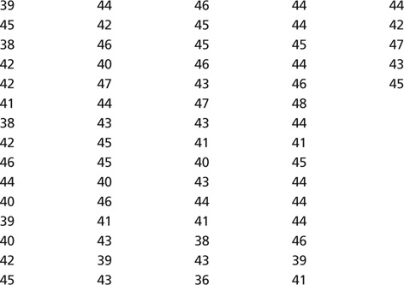
Solution:
a.
b. Yes, 95% interval is above 42.
- Yes, 99% interval is above 42.
- Very confident based on the 99% confidence interval being above 42.

- THE VIDEO GAME SATISFACTION RATING CASE
The mean and the standard deviation of the sample of n=65 customer satisfaction ratings in Table1.7 are =42.95 and s=2.6424. Calculate a t-based 95 percent confidence interval for, the mean of all possible customer satisfaction ratings for the XYZ Box video game system. Are we 95 percent confident that is at least 42, the minimal rating given by a very satisfied customer?
Solution:
t-based: [42.308, 43.592]
Yes, because interval is greater than 42.

- Referring to Exercise 8.20(page320), regard the sample of 10 sales figures for which s=32.866 as a preliminary sample. How large a sample of sales figures is needed to make us 95 percent confident that, the sample mean sales dollars per square foot, is within a margin of error of $10 of , the true mean sales dollars per square foot for all Whole Foods supermarkets.
Solution:

So, we need 56 samples figures to make us 95 percent confident that is within a margin
of error of $10 of.

